Error Handling
When using files, IOExceptions need to be continuously dealt with. At times when the program can move on without worrying about the exception, I throw the exception. Sometimes the work with the files is the main point of a method and therefore needs to be dealt with using a try-catch block that tells the user when an error occurs and what the action was that created it.
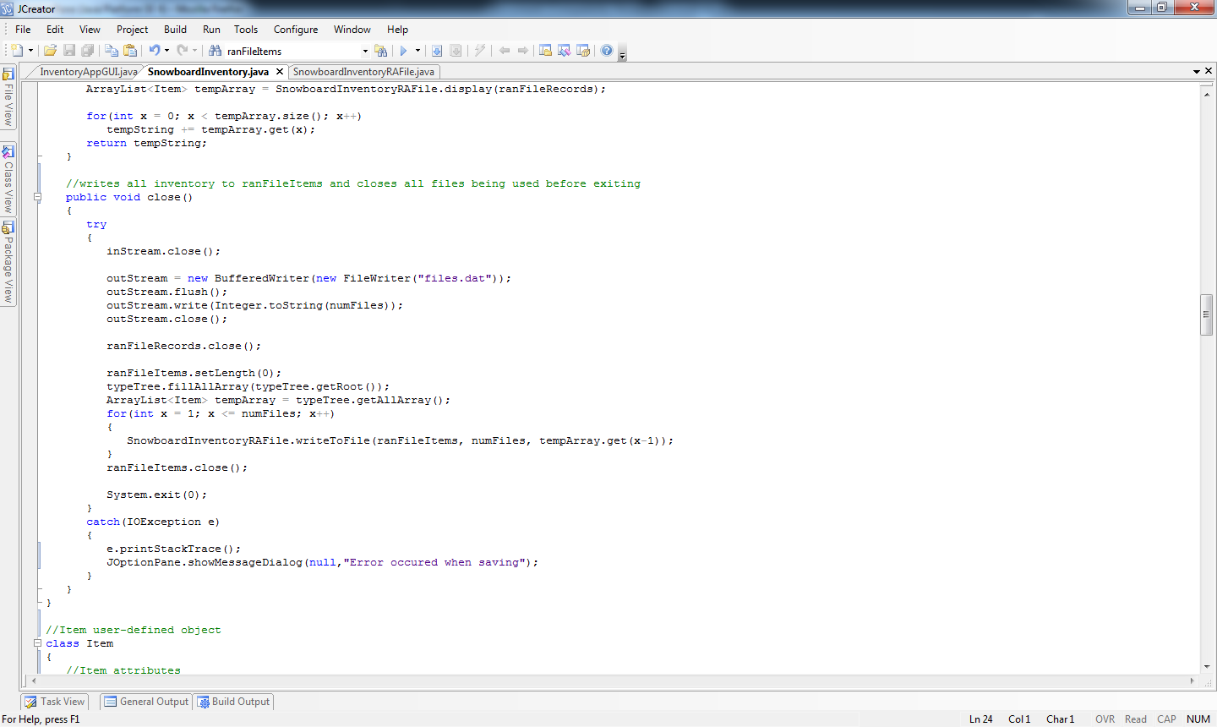

User-input is also checked for errors. Users of an inventory program will range from middle-school graduates to college graduates which means it needs to be simple enough to use and able to compensate for a users wrong input.

    

